Step 3. Detector-Forward Transformation of Intrinsic UPE Spectra
To determine how wavelength-dependent detector sensitivity modifies the biologically generated UPE spectrum, the nominal intrinsic spectra were propagated through the H7360 detector-response function used for the respiratory-burst comparison. This analysis was performed separately from the intrinsic spectral calculation so that changes produced by the measurement system were not misinterpreted as biological spectral redistribution.
The detector response substantially compressed the apparent wavelength differences among conditions. The full intrinsic spectral centroid increased from 523.13 nm in the healthy condition to 567.77 nm for severe COVID-19 and 588.09 nm for sepsis. When the intrinsic spectra were first restricted to the 300–650 nm H7360 sensitivity window, the corresponding centroids were 506.71, 521.66, and 528.34 nm. After wavelength-dependent detector weighting, the centroids shifted further toward shorter wavelengths, to 482.08 nm for healthy, 487.04 nm for COVID-19, and 489.00 nm for sepsis (Table 1; Figure 1C). Thus, the detector-forward transformation reduced the apparent disease-minus-healthy centroid displacement from 44.63 to 4.96 nm for COVID-19 and from 64.96 to 6.93 nm for sepsis.
The change arose because the H7360 response favors the blue-green region of the modeled spectrum and declines toward longer wavelengths. Consequently, the detector-weighted spectral peaks occurred at 467.5, 470.5, and 471.5 nm for healthy, COVID-19, and sepsis, respectively, even though the corresponding intrinsic peaks within the detector window were 479.5, 484.5, and 633.5 nm. The sepsis spectrum therefore illustrates an important measurement effect: a strong intrinsic long-wavelength contribution can be strongly attenuated by detector response and may not appear as the dominant measured peak (Figure 1A,B).
The detector window also excluded part of the intrinsic emission. Approximately 93.1% of the modeled healthy spectral area, 84.8% of the COVID-19 area, and 81.1% of the sepsis area fell within 300–650 nm (Table 1). The decreasing captured fraction with increasing oxidative burden is consistent with the modeled redistribution toward longer-wavelength channels. Despite this spectral compression, the integrated detector-weighted signal retained a strong disease ordering, with nominal detector-weighted areas of 1.00-, 34.36-, and 65.58-fold relative to healthy for healthy, COVID-19, and sepsis, respectively.
These results show that biological and detector-level spectral observables are not interchangeable. The intrinsic model predicts a marked redistribution toward longer wavelengths, whereas the H7360-forward model substantially compresses the observable centroid differences because of its finite wavelength range and nonuniform spectral sensitivity. Accordingly, comparisons between modeled spectra and experimental measurements should be made only after applying the relevant detector-response function. Conversely, recovery of intrinsic disease-associated spectral redistribution will require either detector-response correction or instrumentation with sufficiently broad and well-characterized sensitivity, particularly toward the red and near-infrared regions.
Table 1. Detector-forward transformation of nominal intrinsic UPE spectra.
Condition | Intrinsic centroid, full (nm) | Intrinsic centroid, 300–650 nm | Detector-weighted centroid (nm) | Intrinsic peak, 300–650 nm | Detector-weighted peak (nm) | Intrinsic area in 300–650 nm (%) | Detector-weighted fold vs healthy
Healthy | 523.13 | 506.71 | 482.08 | 479.5 | 467.5 | 93.1 | 1.00
COVID-19 | 567.77 | 521.66 | 487.04 | 484.5 | 470.5 | 84.8 | 34.36
Sepsis | 588.09 | 528.34 | 489.00 | 633.5 | 471.5 | 81.1 | 65.58
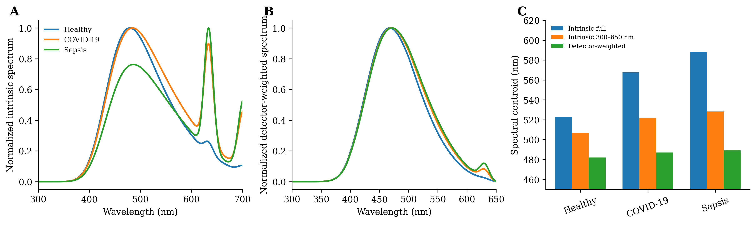
Figure 1. Detector-forward transformation of nominal UPE spectra. (A) Intrinsic spectra within the visible detector region, normalized to the maximum of each condition. (B) Corresponding spectra after multiplication by the wavelength-dependent H7360 detector-response function. (C) Comparison of the full intrinsic centroid, the intrinsic centroid restricted to the 300–650 nm detector window, and the detector-weighted centroid. Detector weighting strongly compresses the apparent disease-associated centroid differences while preserving the ordering of integrated detector signal.
Recommended manuscript placement. Insert this result after the wavelength-resolved structural analyses and before the final summary of findings. The final subsection number should be assigned after the temporal, uncertainty, empirical-basis, and Franck–Condon sections are integrated.

